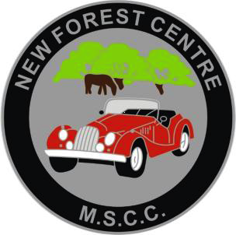 LOGMOG POLO SHIRT ORDER FORM

Please complete this form and email to regalia@logmog.co.uk

Please pay when ordering:
MSCC NEW FOREST
40-22-17 91774379
HSBC UK BANK PLC

It’s strongly recommended a sample be tried for sizing prior ordering. Refunds will not be permitted unless faulty.

SIZING: Men’s: XS/S/M/L/XL/XXL/ to 7XL
Ladies: XS/S/M/L / up to 4XL

Please insert X in the appropriate column.
NAME | MENS | LADIES | SIZE | COLOUR | £17.00
TOTAL PAYMENT

SIGNED & DATE :

Mens Polo Shirt Colours

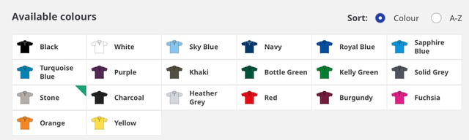

Ladies Polo Shirt Colours

